Learning Outcome 1

Conceptualize, design, and develop interactive media products

You create engaging concepts and translate them into interactive validated media products by applying user-centered design principles, visual design techniques and by exploring emerging trends and developments in media, design and technologies.

* 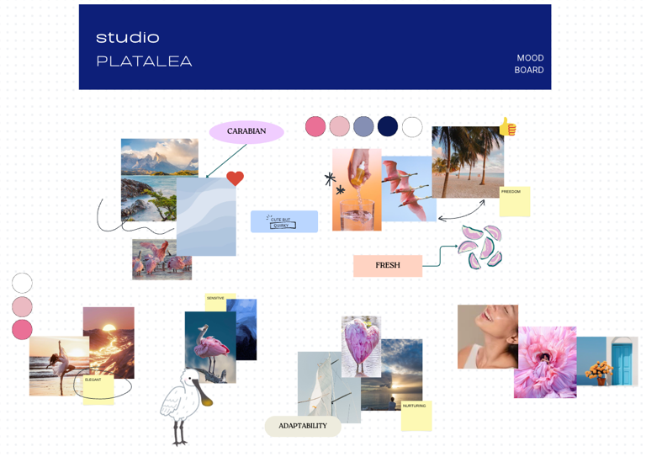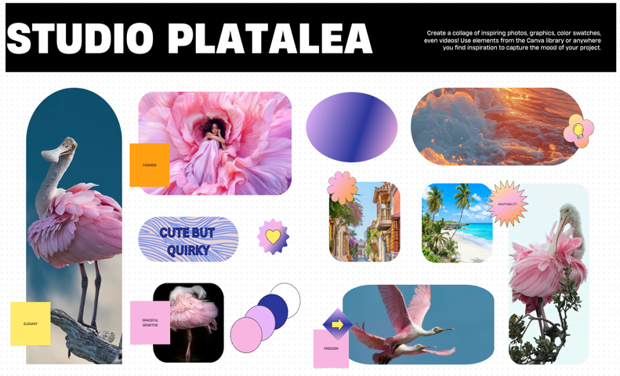**Moodboard:** I created two moodboards with the image I had in my mind for what our group represents. I searched on pinterest the key word I thought of, picked out the images that speaked to me the most.

They difference between them is the amount of pictures there is. The one that has less makes it easier to understand and get to the point, however the other one gets more in detail, making sure the person understands as much as possible.

[**https://www.figma.com/design/D0AByBnS26DElhhpjlQ0ip/Studio-Platalea?node-id=102-2&t=SI2JhDGscAewHT9e-1**](https://www.figma.com/design/D0AByBnS26DElhhpjlQ0ip/Studio-Platalea?node-id=102-2&t=SI2JhDGscAewHT9e-1)

* 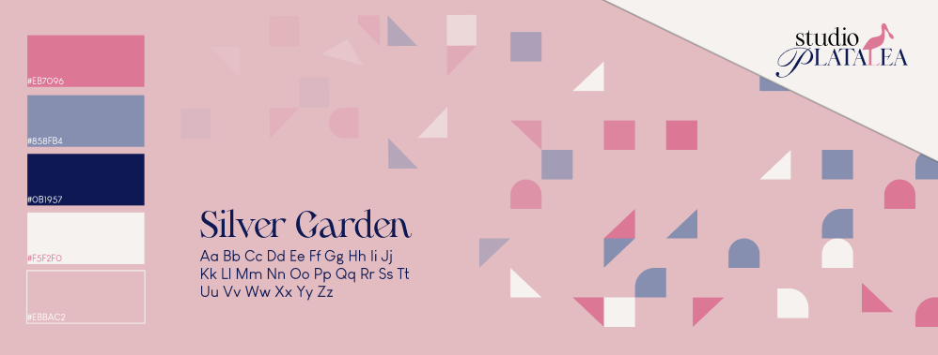**Stylescape:** A more refined visual direction, establishing the brand identity.

I decided to add the main and final products we had for our brand into the stylescape. Adding fading out shapes with our color palette makes it more interesting, colorful and eye catching.

**<https://www.figma.com/design/D0AByBnS26DElhhpjlQ0ip/Studio-Platalea?node-id=102-2&t=SI2JhDGscAewHT9e-1>**

* 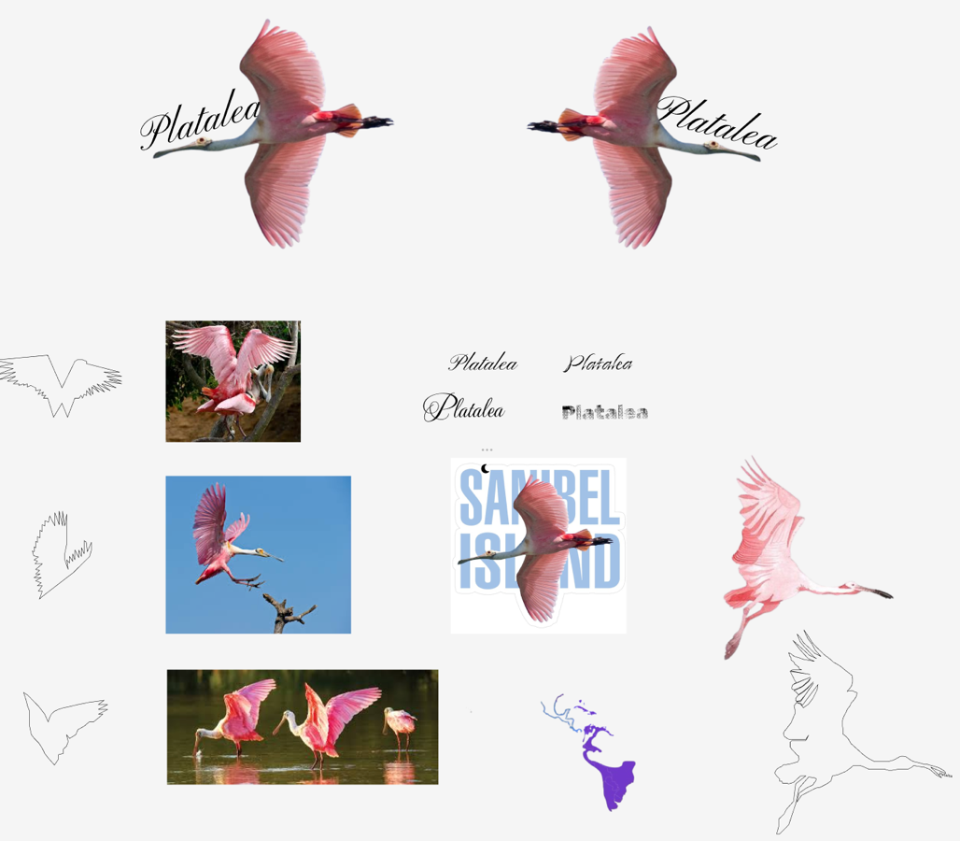**Logo Design:** I went ahead and picked out a few images of the platalea bird, outlined them while having in mind to either just have the outline as our logo or

make it apart of the name. I didn’t really like the outcomes and neither did the group like their own work so we decided to have the words ‘studio platalea’. Adaline had a drawing of the bird in which I had a vision to put it on the ‘I’ of the name, everyone loved it, so we left it like so.

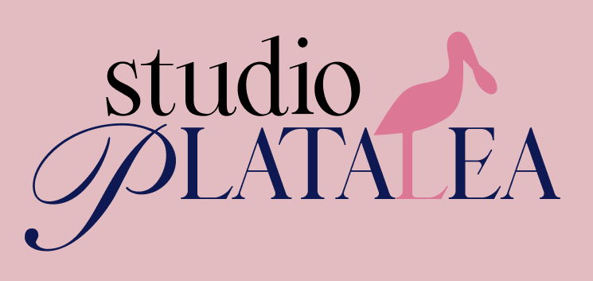

[**https://www.figma.com/design/D0AByBnS26DElhhpjlQ0ip/Studio-Platalea?node-id=0-1&t=SI2JhDGscAewHT9e-1**](https://www.figma.com/design/D0AByBnS26DElhhpjlQ0ip/Studio-Platalea?node-id=0-1&t=SI2JhDGscAewHT9e-1)

* 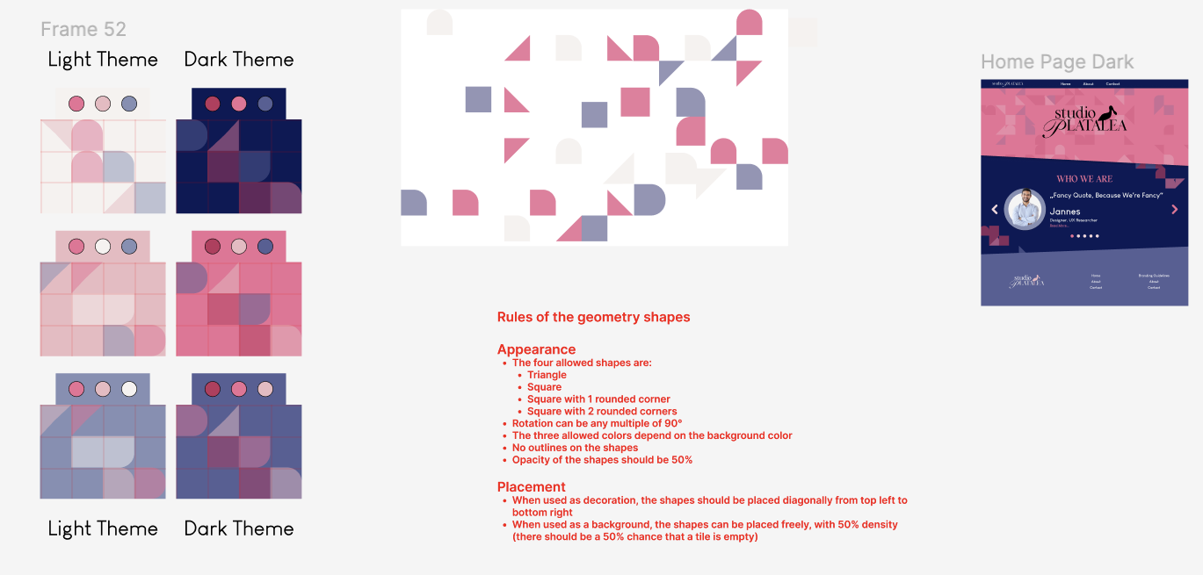**Shapes in Stylescape & Website:** When Andy was creating the prototype of the website I thought there was something missing so I suggested to add the shapes I added in the stylescape. I also proposed we make them move around gently.

**<https://www.figma.com/design/D0AByBnS26DElhhpjlQ0ip/Studio-Platalea?node-id=247-102&t=SI2JhDGscAewHT9e-1>**

* **Poster:**

As part of our project, my team and I were tasked with creating a poster to represent our concept. We began by individually seeking inspiration and developing our own poster drafts. The idea was to gather feedback on each design and collaboratively refine the one that resonated the most with the group.

For my approach, I turned to Pinterest for inspiration, focusing on designs that were visually engaging—something that would catch someone’s attention at a glance. I collected various ideas and brought them into Figma, where I experimented with combining the elements I found most compelling.

After sharing my design with the group, I received feedback that, while the visuals were strong, the layout felt a bit too busy. It needed to be clearer and more focused. We also talked to our teacher, Josh, who clarified that the goal wasn’t to create an advertisement, but an informative poster that clearly communicates the essence of our product.

Taking that into account, I started fresh with a clean white background. I included our brand name, the company we’re collaborating with (Krom), and the core values of our project. Since dyslexia is the central focus, I made sure it stood out prominently. I used Krom’s signature orange color—not only to stay on brand, but also because it's bright and attention-grabbing.

Once I presented the revised version to the team, everyone responded positively. We collectively agreed to move forward with it as our final poster. To help visualize our concept, we added an illustration of a laptop displaying a questionnaire-style game—highlighting our aim to raise awareness about dyslexia through interactive and engaging methods.

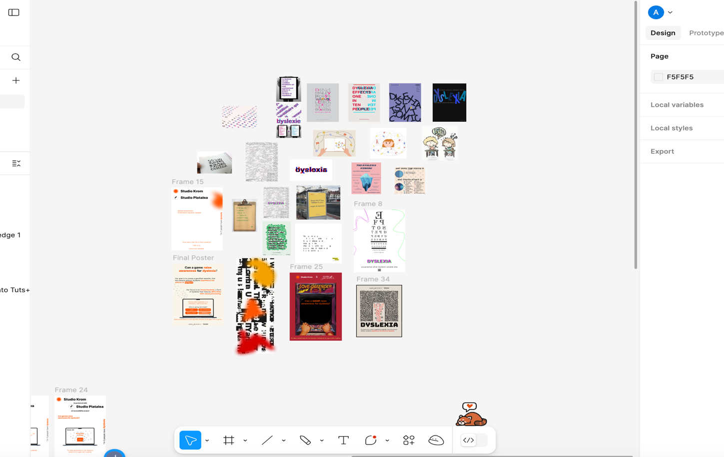

<https://www.figma.com/design/mU9J04F4DDApTGvS5n7lBA/Dyslexia-Things?node-id=0-1&m=dev&t=nblegwtpMWIENDX8-1>

* **Personas:**

To better understand our target audience and design a solution that truly meets their needs, i created user personas. i started by identifying the main types of users who would benefit from our project. This involved discussing potential users' backgrounds, goals, challenges, and behaviors related to our topic—dyslexia.

I gathered insights from initial research, including online articles, user interviews. From this, i began sketching out profiles that represented real user groups. Each persona included details like age, occupation, goals, frustrations.

The goal was to create realistic characters that could help guide our design decisions. For example, i created as one of our key personas a child with dyslexia, highlighting the difficulties they face in a learning environment and what kind of support they would find helpful. And another persona of a teacher, because I think teachers would be one of our most common users, trying to understand their students with dyslexia.

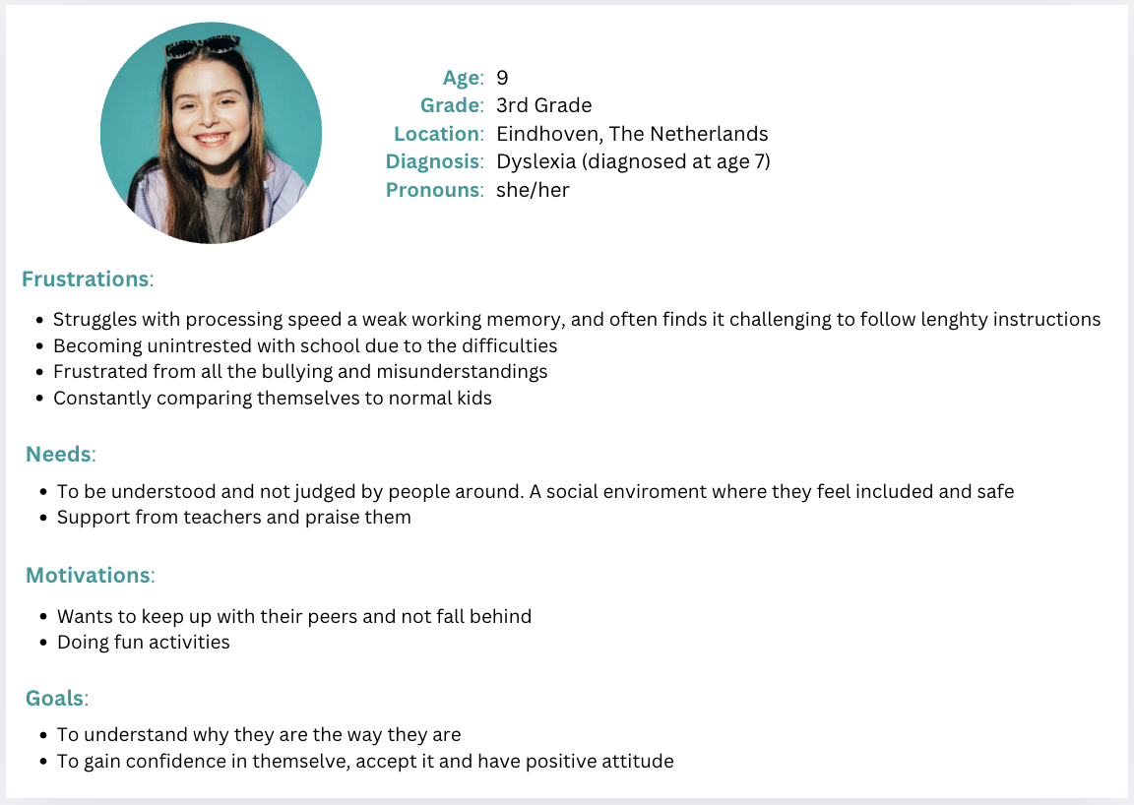Throughout the design process, these personas helped us stay user-centered. They reminded us to think from the user’s perspective and prioritize clarity, accessibility, and engagement in our project.

<https://www.canva.com/design/DAGipg2x_sI/4kgWFu6uLC_wPli45p0U_Q/edit?utm_content=DAGipg2x_sI&utm_campaign=designshare&utm_medium=link2&utm_source=sharebutton>

* **Portfolio Design:**

I still do not have a final Figma design of my portfolio but I have some ideas I want to for sure add. My idea is to make it very artsy, colorful and creative as possible.

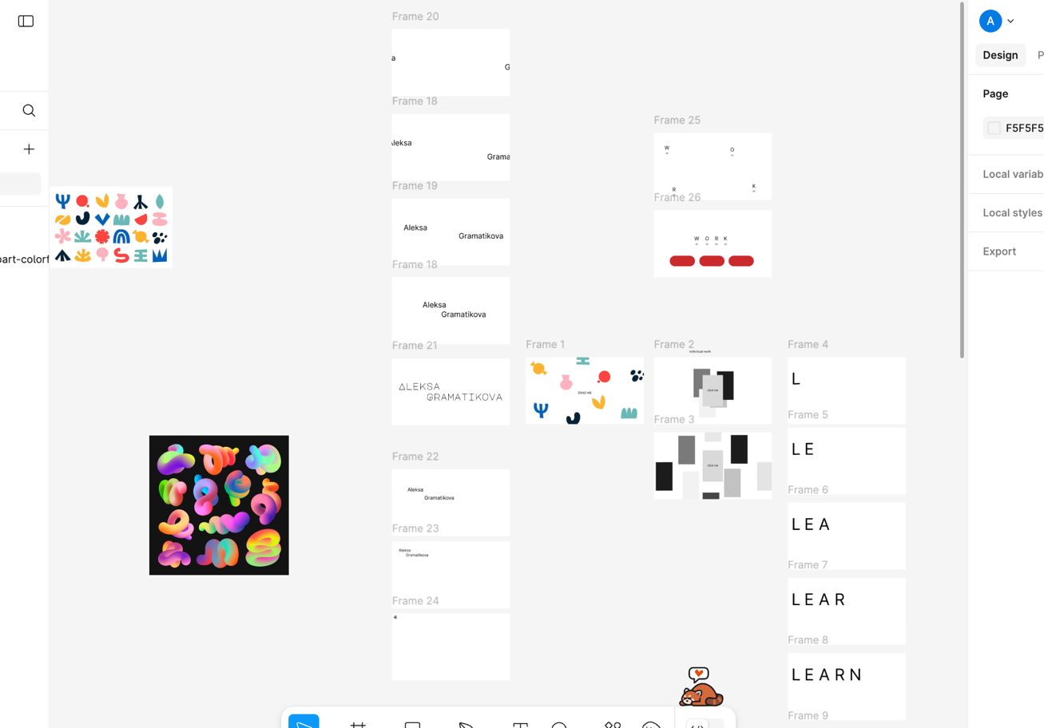

<https://www.figma.com/design/eyT866pli9pdFFAzqYZ2fu/Untitled?node-id=0-1&m=dev&t=UtnJIY1ycbIbqVFQ-1>

* **Figma design for Project Dyslexia:**

After officially needing to start designing our website, me and my group started brainstorming and discussing what it needs to have. We grabbed a whiteboard and started on sketching and discussing.

Firstly we wrote down our goals out of this project, which were:

-raise awareness for dyslexia, provide an effect as close as possible to the real way of seeing with the illness, have a game included into the way of showing how it feels like to be dyslexic and finally have the website not only showcasing one type of dyslexia but at least three of them.

Coming to 6 pages for our website we started to perfect them little by little – if its really needed, if it is fun or boring, etc. Adjusting the ‘Gameplay Page’ into having a good plan I suggested having levels into the game so the first paragraph being short and not so hard to read and with each level getting harder and bigger text, so that way we not only make it an actual game but we also show different types of dyslexia, another idea I had was having the users read the text as normal while a timer tracks how fast they do so, and after that they get a similar text with a timer again, so that way they could see how having dyslexia effects the speed you read in because it is common that kids bully those with dyslexia for being a slow reader. Sadly my teammates didn’t want to implement neither of those ideas because they didn’t want it to have levels so that it feels too gamified. We all tried to find the perfect layout for the ‘Detailed Info Page’, thinking if horizontal or vertical, where should the effect adjustment section be placed, etc. I suggested having points and a timer for the ‘Victory Page’ so that way it feels more like a game rather than some test/quiz.

After pretty much finalizing all of the pages we divided on to who wants to prototype which pages. I chose the gameplay and the victory page. Me and the group agreed that we should use the same colors from our poster so we keep the theme. At first I just added a big paragraph about information for dyslexia and three simple question on the other side of the screen with the idea that the user could read and answer the questions at the meantime, or if wanted to make it more challenging – minimalize/remove the paragraph from the screen so that way they have to first read and then answer. I didn’t fancy the way it looked because I felt it too cramped and demotivating, making it very likely the user lost interest and left. So to fix that I section each small paragraph into a single question, still keeping the information being for the illness so the game not only helps the user see thru a dyslexic’s person’s eyes, but also make them have some knowledge about it. I then made the answer options different from one another – have an one option answer, a multichoice one and a fill in the black one. I shared the final product to my group but they did not approve the idea of different answer options, because they want to keep the website as simple as possible and focus only into bringing awareness, so that is why I went that way and kept it only an one option answer.

After having a feedback session about the whole prototype and idea of the project with Chris, I really wanted to spice up the website and the game, I felt like we needed to make it more gamified to keep as much as possible the user interested and fun, so I started searching some games with some simple designs. I went for the little spaceship that has a marked way ahead of it, but my team didn’t enjoy it because it looked like it resembled levels, so that is why I made the option that when you hover over each dot/location it actually the level of hardnesses Andy already made, but once again they didn’t want to make it too gamy.

For the Victory page I kept it simple for my group, having a little idea of putting some fireworks or confetti on the top falling down. After that Adeline made this cool design of letters scattered around the screen so that gave me an idea for improvement – replacing the confetti with the letters.

After pretty finalizing my pages ii decided to user test so for that I made a couple options for the layout of the gameplay page. I thought how could people possibly prefer it and made it, have each paragraph be specifically sectioned to their own question either horizontal or vertical, having each one of them individually on the screen or completely change it with some funny super simple text in which the users wont get bored or feel like they are doing school work. After doing some testing, it came to two options – the text being vertical and sectioned individually or have each one of them on their own on the screen. In my opinion having the text and questions individually on the screen was having too much space making it difficult for us because if we filled in the spaces with some design it would make it too crowded and harder to concentrate or if we kept it as it is, it would be too simple, boring and quite unprofessional, there for we stuck to the other way.

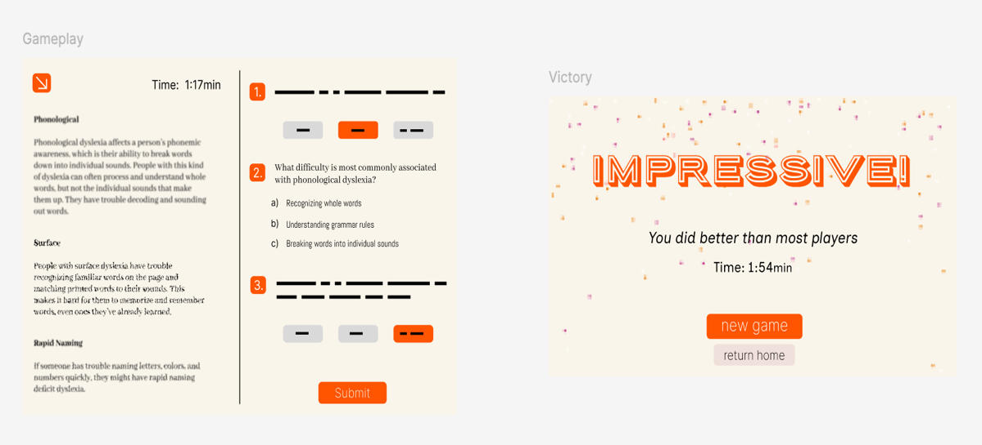

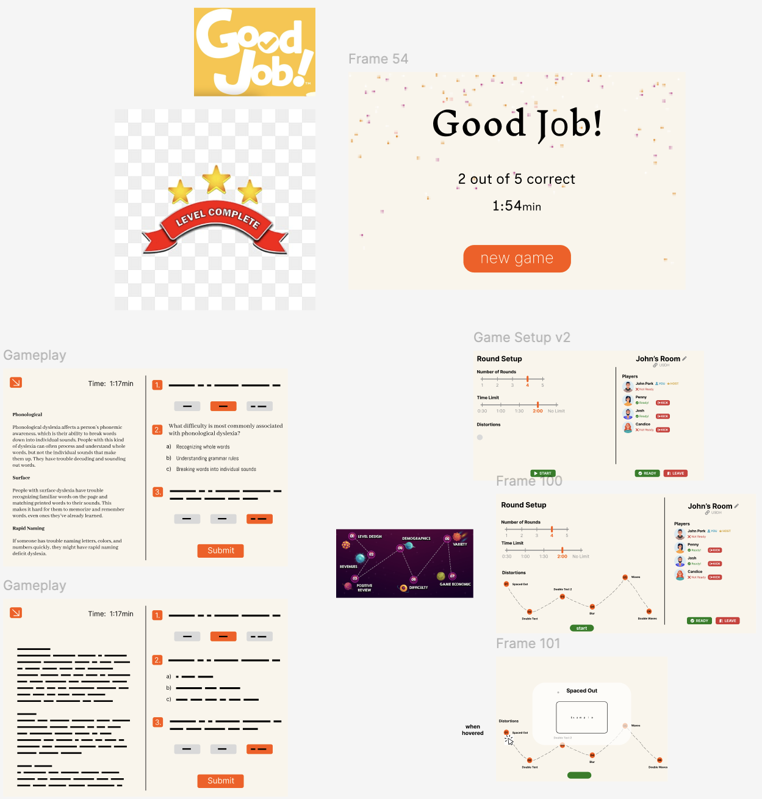

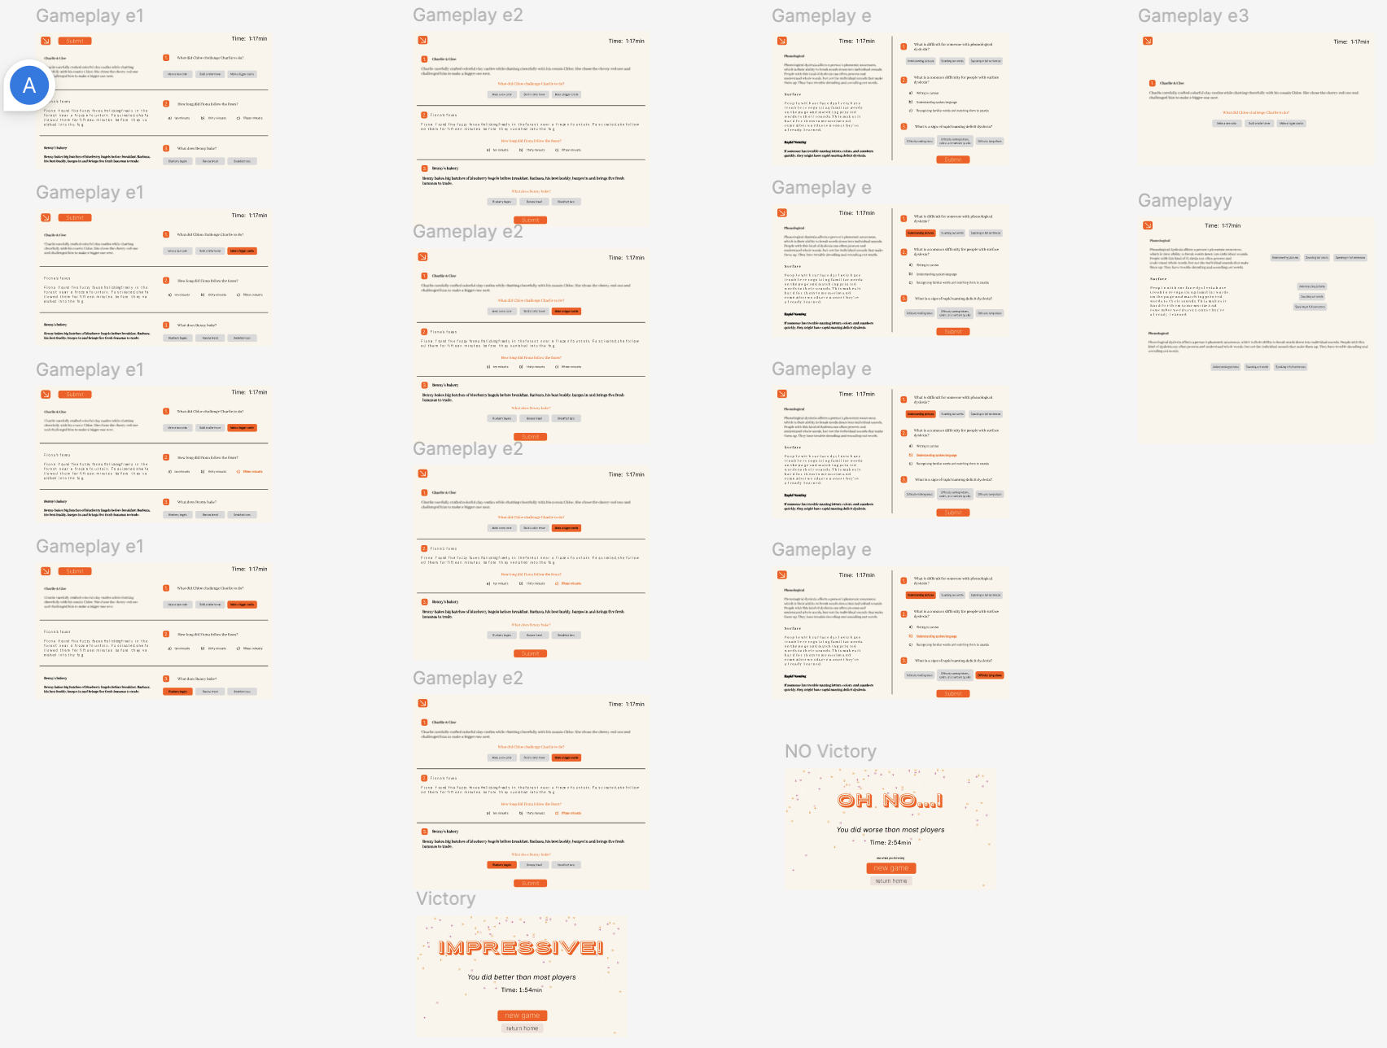

* **Figma Design for Project Dyslexia**

Once we officially started designing our website, my group and I began brainstorming what it should include. We grabbed a whiteboard (like in the photo) and started sketching and discussing.

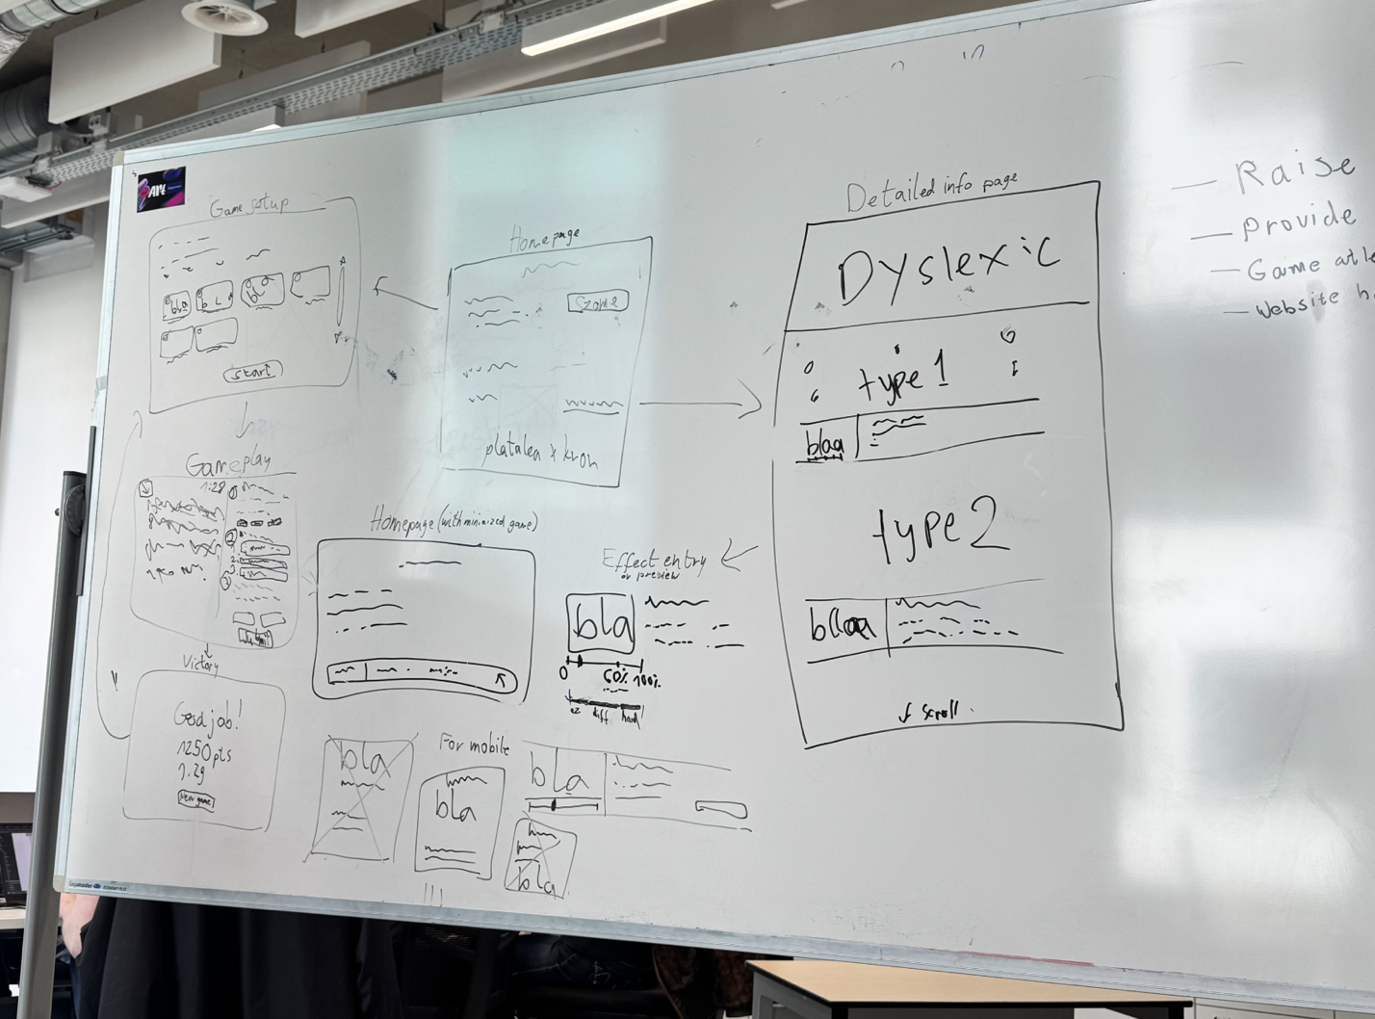

We first defined our main goals for the project:

* Raise awareness about dyslexia
* Simulate how it feels to live with the condition
* Include a game that shows the challenges dyslexic people face
* Present multiple types of dyslexia, not just one

After deciding on six main pages for the site, we worked on improving each one and checking if it made sense, if it was fun, or if it was too boring.

For the gameplay page, I suggested adding levels: starting with easier, shorter texts and increasing difficulty to show different dyslexia types. I also had the idea of timing users while they read a normal paragraph, then comparing it with a dyslexia-effect version, to show how reading speed changes. This would help raise awareness, especially about how dyslexic kids are often bullied for reading slowly. Unfortunately, my teammates felt this made it too much like a game, so those ideas didn’t make it in.

We spent some time discussing the layout for the detailed info page, whether to go horizontal or vertical, and where the dyslexia effect toggle should be.

For the victory page, I suggested a point system and a timer to make it feel more rewarding.

Once we finalized the page structure, we divided the prototyping tasks. I chose the game setup and victory pages. I thought we should continue on using the same color theme as our poster to keep everything consistent.

At first, for the game setup, I had a big info paragraph on one side and three questions on the other, but it felt cramped and uninviting. So, I changed it: each paragraph became its own question, keeping the focus on educating users about dyslexia while making it interactive. I also tried using different answer types like multiple choice, fill-in-the-blank, etc. but the group wanted to keep things simple, so we stuck with one-answer options only.

After our feedback session with Chris, I wanted to make the game side more fun to keep users engaged. I explored simple game designs, thought of Chris’s idea for FlexBox Froggy, checked out other websites and came up with a spaceship path idea, where each dot represented a difficulty level. But again, the team felt this was “too gamified.”

For the victory page, I kept it light: I first thought of adding fireworks or confetti. Then Adeline made a design with scattered letters, which inspired me to swap the confetti with falling letters to stay on theme. This is still a goal for the future because we felt like it would be too much letters.

After mostly finalizing my pages, I decided to do some user testing. I created a few layout options for the gameplay page, thinking about what users might prefer. I tried having each paragraph linked to its own question, either arranged horizontally or vertically, showing them individually on the screen. I also tested a completely different version with funny, super simple text so users wouldn't get bored or feel like they were doing schoolwork.

After testing, it came down to two options: vertical text with each section and question together, or showing them one at a time on separate screens. In my opinion, having everything individually on the screen left too much empty space. If we filled the space with design, it became too crowded and hard to focus. But if we left it as-is, it felt too simple, boring, and kind of unprofessional. So i stuck with the first option instead.





* **New Portfolio Design:**

After sticking to a black with some colors design for the two portfolio submissions I realized I didn’t really feel connected and proud of it so I decided the best idea was to change it. I went onto different social media platforms trying to find some inspirations, and as always Pinterest helped me out with just a simple picture that is known for being the original windows wallpaper. I have seen other people turn their portfolios into a MacBook screen so I decided to do a windows screen. I searched on TikTok for that and luckily for me there was a page for front end designs. There was a lot of fun and interesting ideas but I. just had my mind fixated to the windows design.

**Learning Outcome 1**

**Conceptualize, Design, and Develop Interactive Media Products**  
*You create engaging concepts and translate them into interactive validated media products by applying user-centered design principles, visual design techniques and by exploring emerging trends and developments in media, design and technologies.*

**🎨 Moodboards**

To begin our concept development, I created two moodboards on Figma that reflect the creative direction and personality of our group. I searched for inspiration on Pinterest using keywords that captured our intended tone - creative, bold, elegant and some images that visually spoke to me.

* The first moodboard is minimal and straightforward, making the concept easy to grasp.
* The second includes more images, offering a deeper dive into the brand’s aesthetic

Feedback: My group gave me positive feedback, they did enjoy the way it was clean yet colorful and artsy. We had to chose just a few of the moodboards in order to make a final one, representing our brand. Mine was one of them, so later on we combined a few pictures from mine to the finalized one.

Reflection: Making the moodboards was honestly one of my favorite parts of the project. It let me express how I pictured our brand in my head—creative, artsy, and a bit bold. I just followed what felt right visually and it ended up connecting with the group. They liked how clean and colorful it was, which gave me more confidence in my creative choices.

Looking back though, I probably spent too much time on Pinterest and ended up overthinking which images to include. I could’ve been faster or narrowed it down earlier. Still, the fact that some of my images were used in the final version made me feel like my input had value, and I also saw how helpful it is to combine different perspectives to build something better as a team.

📎 [Moodboards on Figma](https://www.figma.com/design/D0AByBnS26DElhhpjlQ0ip/Studio-Platalea?node-id=102-2&t=SI2JhDGscAewHT9e-1)

**🧩 Stylescape**

To have a clear visual direction of our product, I contributed on building the stylescape using the colors and mood we had already agreed on. I added some faded shapes and soft elements to bring more personality into the layout. It wasn’t just about making it look nice—this stylescape became the base for everything we designed later, like the poster and website. It really helped us stay consistent and made sure everything felt like it belonged to the same brand.

📎 [Stylescape Link](https://www.figma.com/design/D0AByBnS26DElhhpjlQ0ip/Studio-Platalea?node-id=102-2)

**🪶 Logo Design**

I went ahead and picked out a few images of the Platalea bird, outlined them while having in mind to either just have the outline as our logo or make it apart of the name. I didn’t really like the outcomes and neither did the group like their own work so we decided to have the words ‘studio Platalea’. Adaline had a drawing of the bird in which I suddenly imagined the Pixar lamp intro so I thought to put the bird on the ‘L’ of the name, looking like the legs of the animal. Everyone loved it, so we left it like so.

📎 [Logo in Figma](https://www.figma.com/design/D0AByBnS26DElhhpjlQ0ip/Studio-Platalea?node-id=0-1)

**🌀 Shapes in Stylescape & Web Prototype**

During Andy’s website prototyping, I noticed something was visually missing. I suggested incorporating the playful shapes I had already created in the stylescape. They made the prototype feel more alive and keeping consistency with our visual identity. It added both depth and energy to the interface.

📎 [Shape examples](https://www.figma.com/design/D0AByBnS26DElhhpjlQ0ip/Studio-Platalea?node-id=247-102)

**📣 Poster Design**

As part of our project, my team and I were tasked with creating a poster to represent our concept. We each started by gathering inspiration and designing individual drafts, with the goal of sharing feedback and combining the strongest ideas into a final version.

For my part, I looked through Pinterest for visually striking posters—something bold and attention-grabbing. I brought my favorite elements into Figma and played around with layouts to see what felt the most impactful. When I shared my first draft with the group, they liked the visuals, but felt the layout was too busy and a bit overwhelming. During our feedback session with our teacher Josh, he also reminded us that the goal wasn’t to make an advertisement, but an informative poster that clearly communicates our concept.

So I started over with a simpler, cleaner approach. I used a white background, kept the design light and clear, and made sure to highlight the most important elements: our brand name, the company we’re working with (Krom), and the focus of the project—dyslexia. I used Krom’s signature orange color to make key parts stand out, both to match their brand and grab attention.

The revised version was much better received by the group. We all agreed to move forward with it as our final poster. To tie everything together visually, we also added a small illustration of a laptop displaying a questionnaire-style game, which helped communicate our goal of raising awareness about dyslexia in an interactive and engaging way.

**Reflection:** Working on the poster taught me how important clarity and purpose are in visual design. At first, I was mostly focused on making it look cool and creative, but I realized that if the message isn’t clear, the design doesn’t do its job. It was a bit frustrating to start over after the feedback, but in the end, I’m glad I did. The second version was way more effective, and it actually felt more professional. I also learned how to better balance creativity with function—and that sometimes, simpler really is better.

📎 [Poster on Figma](https://www.figma.com/design/mU9J04F4DDApTGvS5n7lBA/Dyslexia-Things?node-id=0-1)

**👤 User Personas**

To better understand our target audience and design a solution that truly meets their needs, i created user personas. i started by identifying the main types of users who would benefit from our project. This involved discussing potential users' backgrounds, goals, challenges, and behaviors related to our topic—dyslexia. I gathered insights from initial research, including online articles, user interviews. From this, i began sketching out profiles that represented real user groups. Each persona included details like age, occupation, goals, frustrations. The goal was to create realistic characters that could help guide our design decisions. For example, i created as one of our key personas a child with dyslexia, highlighting the difficulties they face in a learning environment and what kind of support they would find helpful. And another persona of a teacher, because I think teachers would be one of our most common users, trying to understand their students with dyslexia. Throughout the design process, these personas helped us stay user-centered. They reminded us to think from the user’s perspective and prioritize clarity, accessibility, and engagement in our project.

Feedback: I got some feedback from Pennie on my personas, and at first she didn’t fully agree with them. She mentioned that a dyslexic person shouldn’t be included as a persona because they aren't technically our “target audience.” But after I explained that they’re actually a key part of who we want to reach, both to test the experience and to give us direct feedback, she understood my point. Since our whole project revolves around their experience, I felt it was important to include them at the center of our process.

📎 [Personas on Canva](https://www.canva.com/design/DAGipg2x_sI/4kgWFu6uLC_wPli45p0U_Q/edit)

**🖥 Portfolio Design Planning**

Although I haven’t finalized my personal portfolio, I’ve started ideating and sketching. My vision is a colorful, artsy layout with strong creative expression, aligning with my personal style and our Studio Platalea branding.

📎 [Portfolio concept](https://www.figma.com/design/eyT866pli9pdFFAzqYZ2fu/Untitled)

**🧪 Website & Gameplay Design**

Once we officially started designing our website, my group and I began brainstorming what it should include. We grabbed a whiteboard (like in the photo) and started sketching and discussing.



We first defined our main goals for the project:

* Raise awareness about dyslexia
* Simulate how it feels to live with the condition
* Include a game that shows the challenges dyslexic people face
* Present multiple types of dyslexia, not just one

After deciding on six main pages for the site, we worked on improving each one and checking if it made sense, if it was fun, or if it was too boring.

For the gameplay page, I suggested adding levels: starting with easier, shorter texts and increasing difficulty to show different dyslexia types. I also had the idea of timing users while they read a normal paragraph, then comparing it with a dyslexia-effect version, to show how reading speed changes. This would help raise awareness, especially about how dyslexic kids are often bullied for reading slowly. Unfortunately, my teammates felt this made it too much like a game, so those ideas didn’t make it in.

We spent some time discussing the layout for the detailed info page, whether to go horizontal or vertical, and where the dyslexia effect toggle should be.

For the victory page, I suggested a point system and a timer to make it feel more rewarding.

Once we finalized the page structure, we divided the prototyping tasks. I chose the game setup and victory pages. I thought we should continue on using the same color theme as our poster to keep everything consistent.

At first, for the game setup, I had a big info paragraph on one side and three questions on the other, but it felt cramped and uninviting. So, I changed it: each paragraph became its own question, keeping the focus on educating users about dyslexia while making it interactive. I also tried using different answer types like multiple choice, fill-in-the-blank, etc. but the group wanted to keep things simple, so we stuck with one-answer options only.

After our feedback session with Chris, I wanted to make the game side more fun to keep users engaged. I explored simple game designs, thought of Chris’s idea for FlexBox Froggy, checked out other websites and came up with a spaceship path idea, where each dot represented a difficulty level. But again, the team felt this was “too gamified.”

For the victory page, I kept it light: I first thought of adding fireworks or confetti. Then Adeline made a design with scattered letters, which inspired me to swap the confetti with falling letters to stay on theme. This is still a goal for the future because we felt like it would be too much letters.

After mostly finalizing my pages, I decided to do some user testing. I created a few layout options for the gameplay page, thinking about what users might prefer. I tried having each paragraph linked to its own question, either arranged horizontally or vertically, showing them individually on the screen. I also tested a completely different version with funny, super simple text so users wouldn't get bored or feel like they were doing schoolwork.

After testing, it came down to two options: vertical text with each section and question together, or showing them one at a time on separate screens. In my opinion, having everything individually on the screen left too much empty space. If we filled the space with design, it became too crowded and hard to focus. But if we left it as-is, it felt too simple, boring, and kind of unprofessional. So i stuck with the first option instead. This process helped me understand real UX preferences and the importance of balance between playfulness and professionalism.

Reflection: This whole planning phase taught me how important it is to combine creativity with what works. I came in with a bunch of ideas that I was really excited about, like using levels or comparing reading speed with and without dyslexia effects. I still think those concepts had a lot of potential to make the experience more meaningful, but I learned that not every idea fits the group's vision. It was a bit frustrating at times, but it helped me understand how to compromise and prioritize the bigger picture.

Seeing our ideas come to life on the whiteboard felt like real progress. It was cool to physically map things out, make changes on the spot, and hear everyone's input. I also learned a lot from the user testing I did later—sometimes what makes sense in your head doesn’t always feel right to others. I kept adjusting layouts and content to find the best balance between education, interaction, and simplicity. In the end, even though not all of my ideas made it in, I’m proud of how much I contributed and how much the process taught me about team communication, flexibility, and design thinking.

**🧠 User Testing & Layout Iteration**

**🔍 Additional Value**

✅ **Accessibility Consideration**  
Even though we didn’t implement accessibility features deeply, I consistently thought about how to support users with dyslexia—like reducing visual clutter, avoiding overly complex text layouts, and ensuring clear readability.

✅ **Emerging Trend Awareness**  
I explored trends such as gamification and micro-interactions to make the learning experience more engaging. While not all were used, the research helped inform what kind of interactivity was appropriate for the topic.

✅ **Responsive Design Planning**  
Although our prototype is primarily desktop-based, I contributed ideas for mobile responsiveness. I suggested potential changes to ensure all pages remain usable and readable across different screen sizes.

✅ **Iterative Feedback Process**  
Every design element I worked on—poster, game page, or stylescape—went through cycles of team feedback and revision. I actively sought teacher input to validate design decisions and adjusted based on real critiques.